Angular Course -2023

* Build BY Microsoft .
* It has routing functionality to create a SPA server side rendering .
* Array list let Gopi: string[]

Filter function;

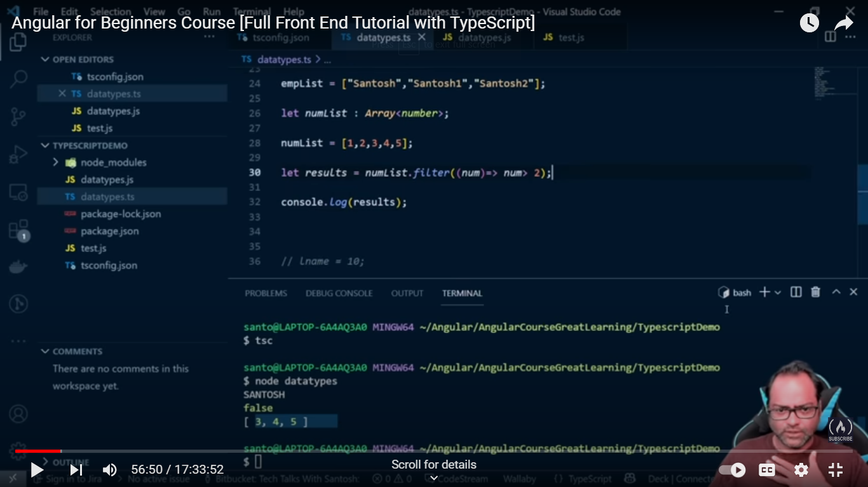

**Find function**

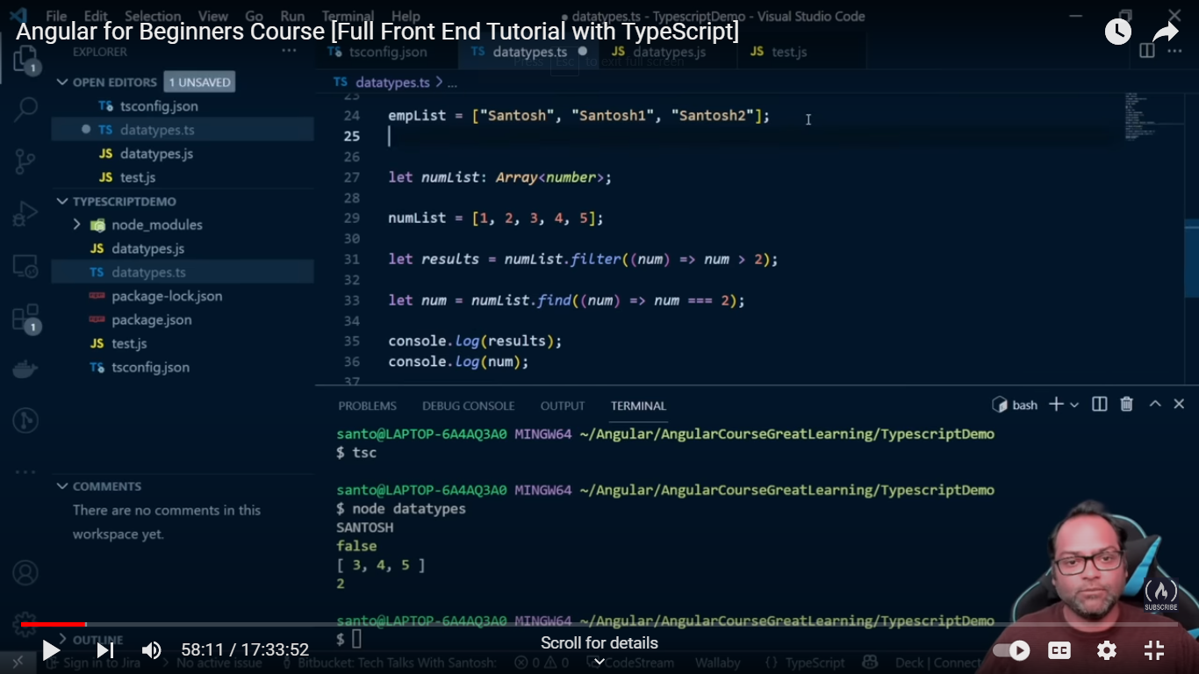

**Angular project structured details**

1.favicon ico => browserla git img irukkum athu

2 polyfils .ts=> if we need to work animation high level that time this poly fill .ts supporting

**Binding :**

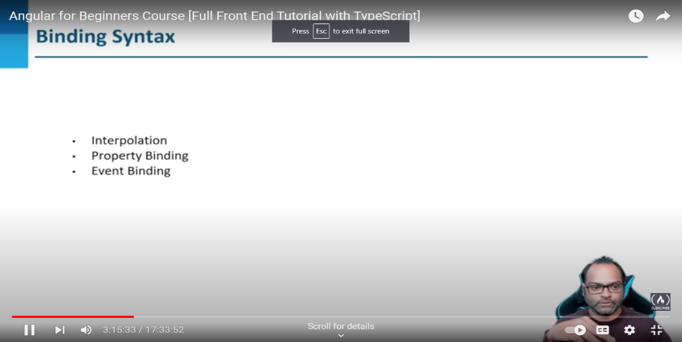

**Interpolation:**

Tsfile= name=”gopi”

Html= <h>{{name}}</h>

**Property binding :**

If valid binding with property we can use this one

Tsfile= name =10;

Html=> <div [innerText]=”name”></div>

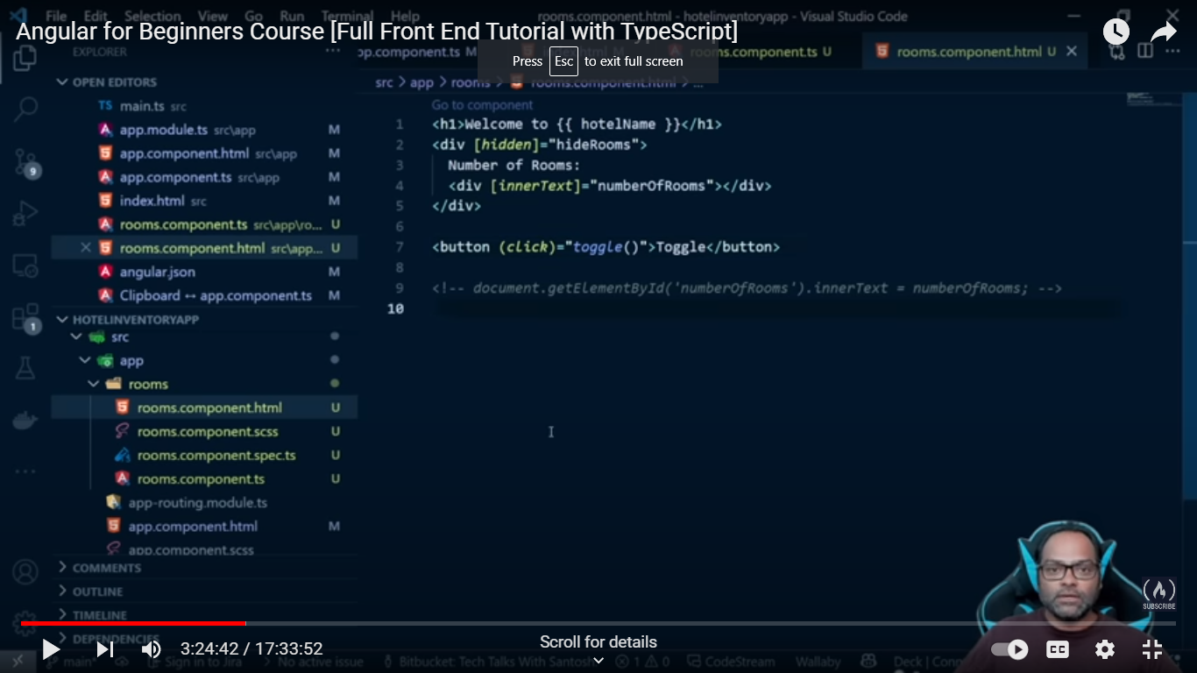

**ngFor Given Two Accesibility:**

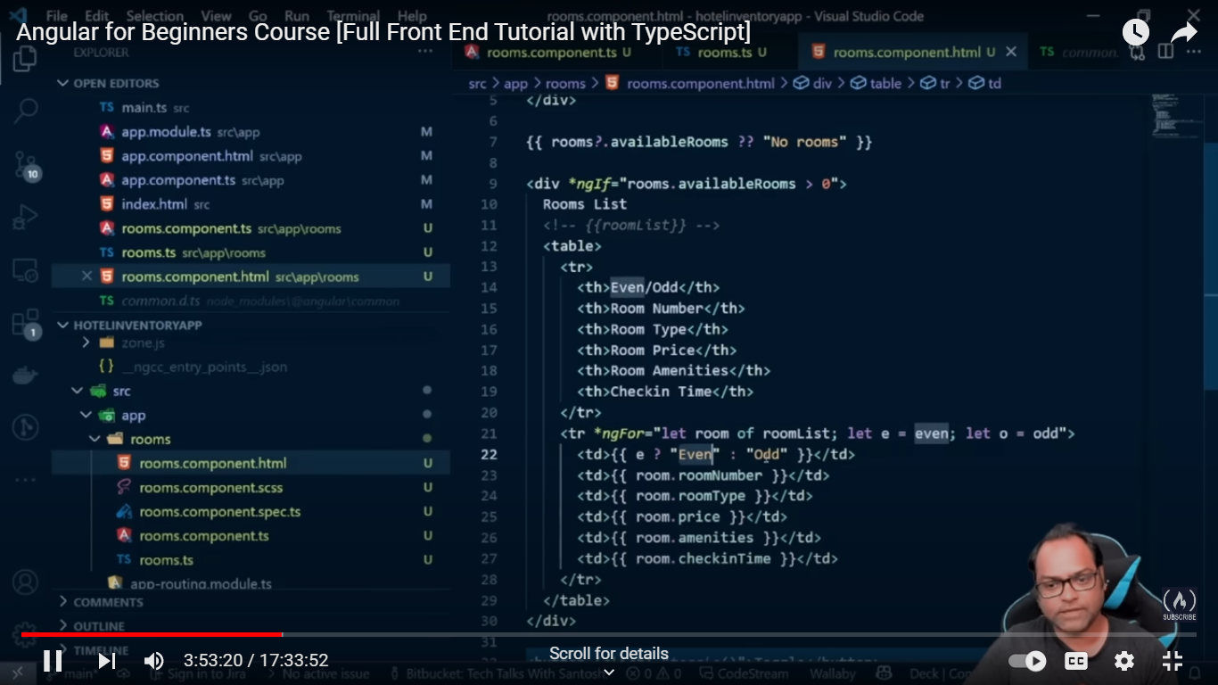

1.find the data event of odd

**ngSwitch:**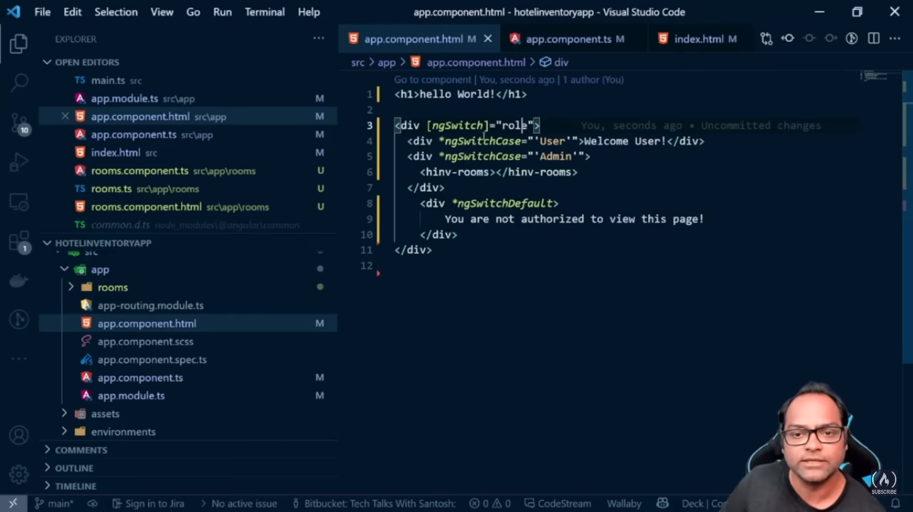

**ngclass :**

1. **Used to separate the common card in same colour.**

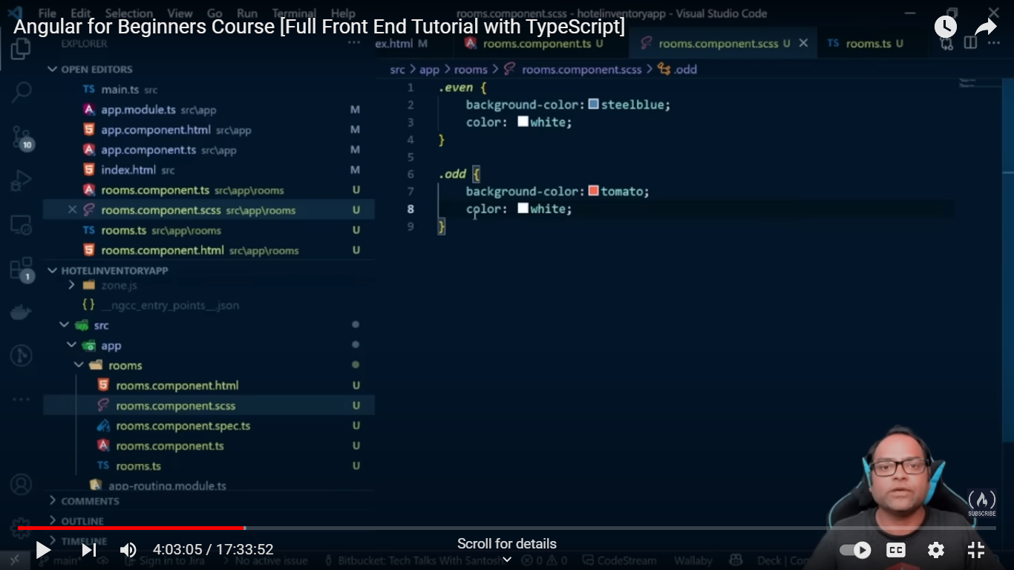

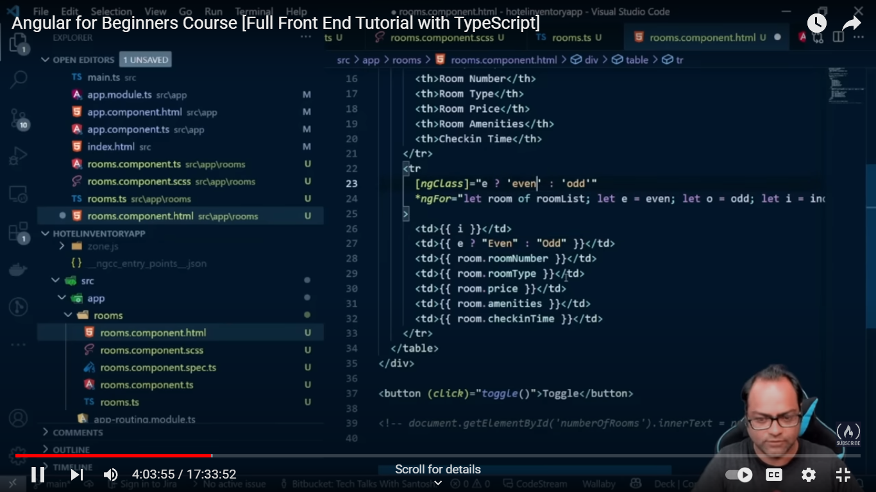

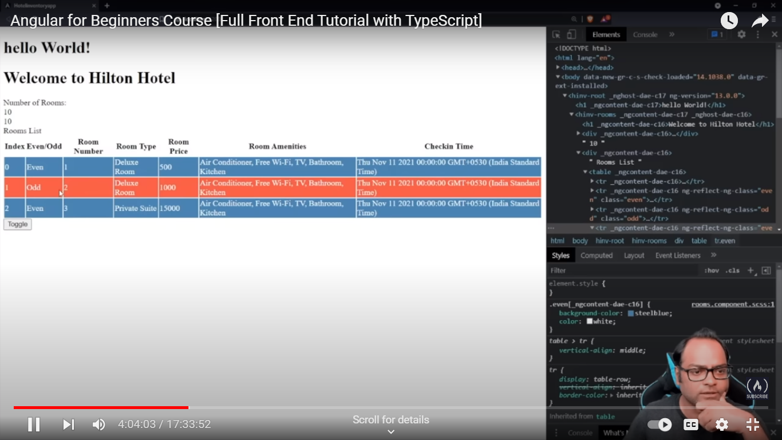

**Ngstyle:**

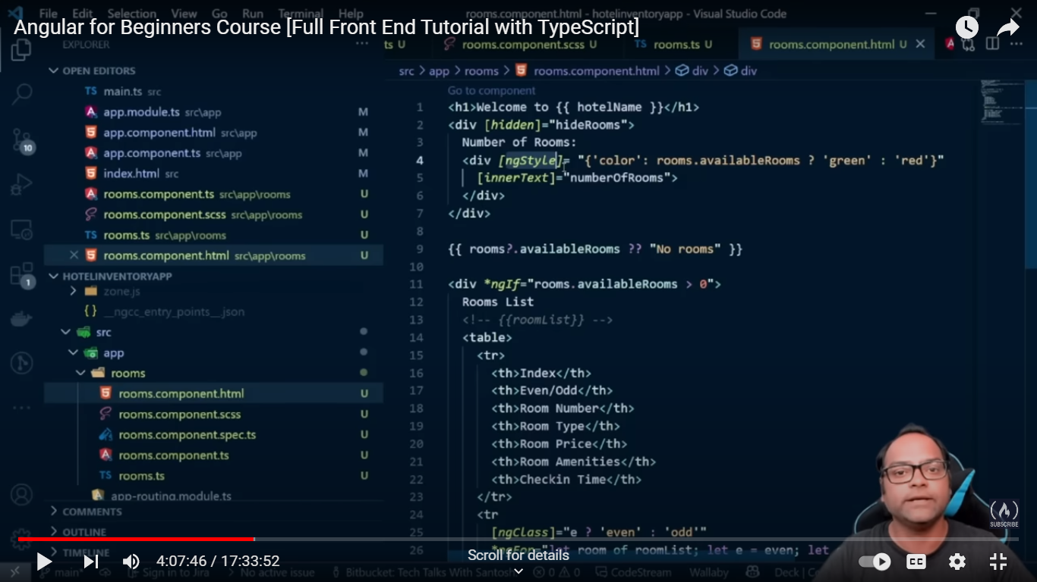

**Pipes:**

**1.Pipes are used for data transformation**

**2.pipes don’t change actual object**

**Datepipe <h>{{gopi | date:’short’}}</h> 11/01/2022**

**Uppercasepipe <h>{{ gopi | uppercase}}</h>**

**Lowecasepipe<h>{{ gopi | lowercase}}</h>**

**Tilecasepipe<h>{{gopi | }}</h>Gopi Saravanan**

**Currencypipe<h>{{gopi | cuurency:’INR’}}</h> $**

**Decimalpipe <h>{{ }}</h>**

**Percentpipe <h>{{ gopi | percent }}</h>%**

**Jsonpipe <h>{{}}</h>**

**Slicepipe <h *ngFor only>{{ gopi | slice :0:1;}}</h>**

**Slice pipe between the data like from date and to date**

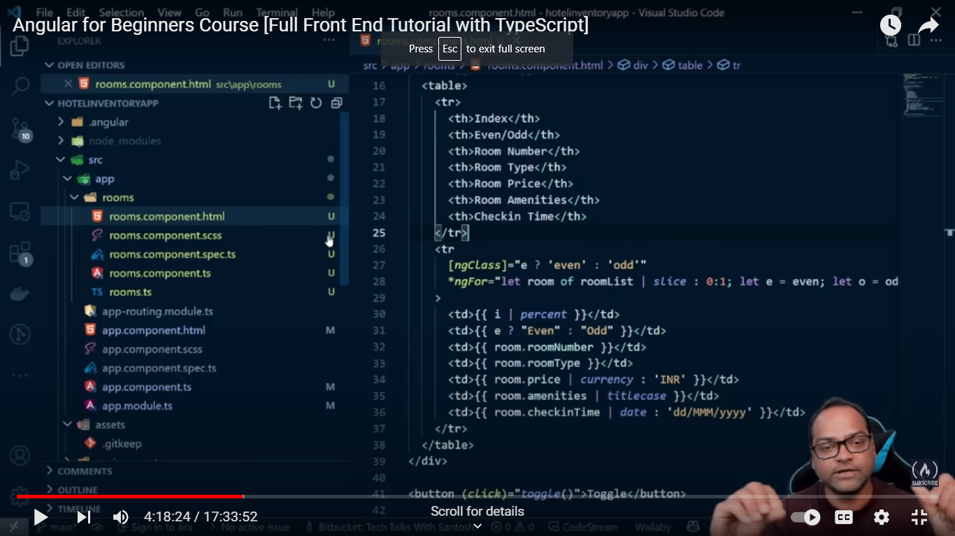

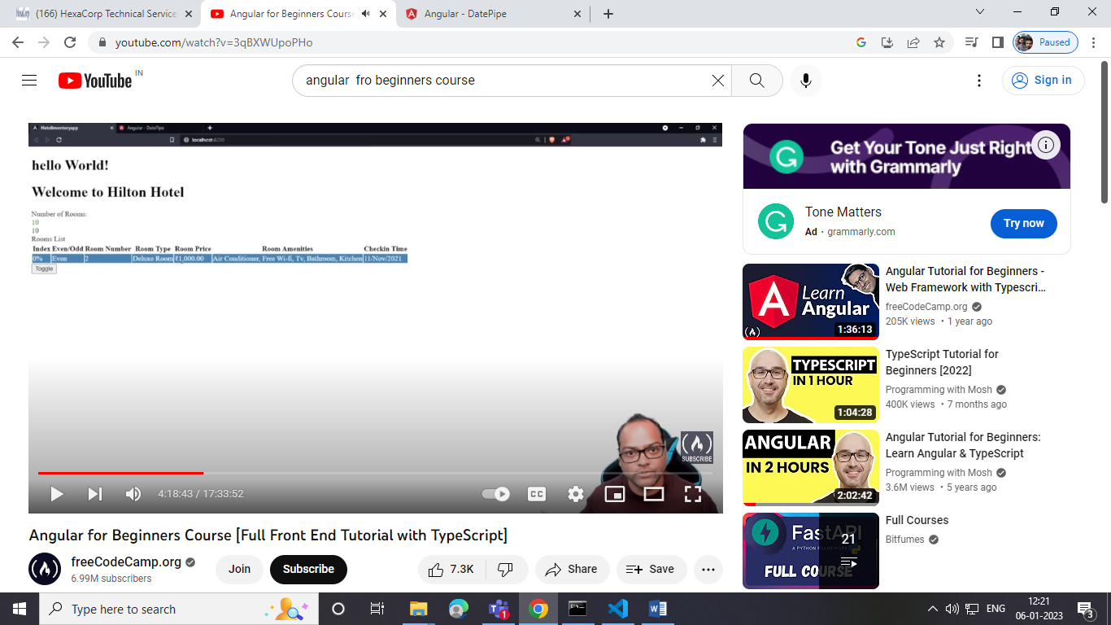

**Life Cycle Hooks:**

**Component instance life cycle hooks which can help you to hook into difference events are components.**

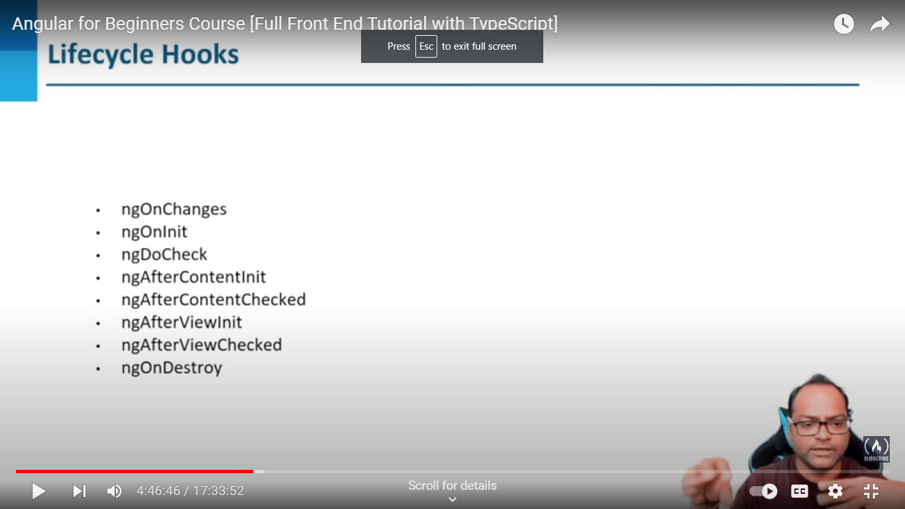

**@input decorator to pass the child to parant:**

**Child component :-**

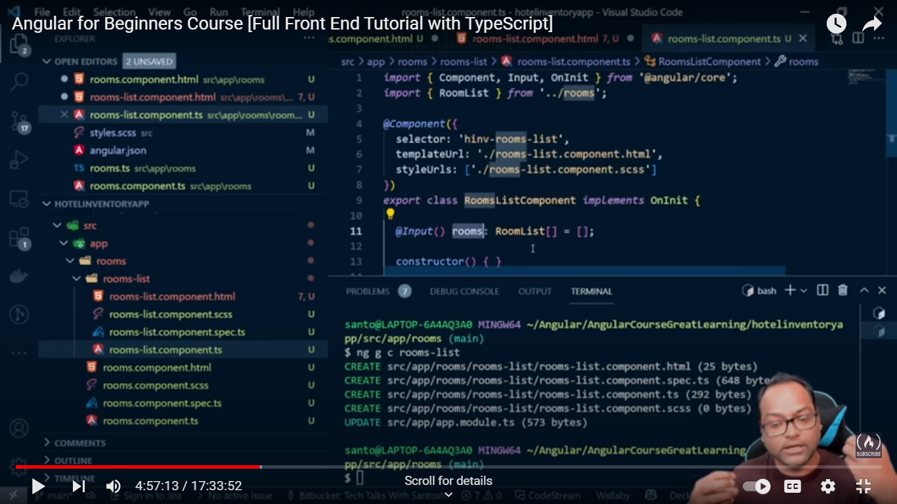

**Parant**

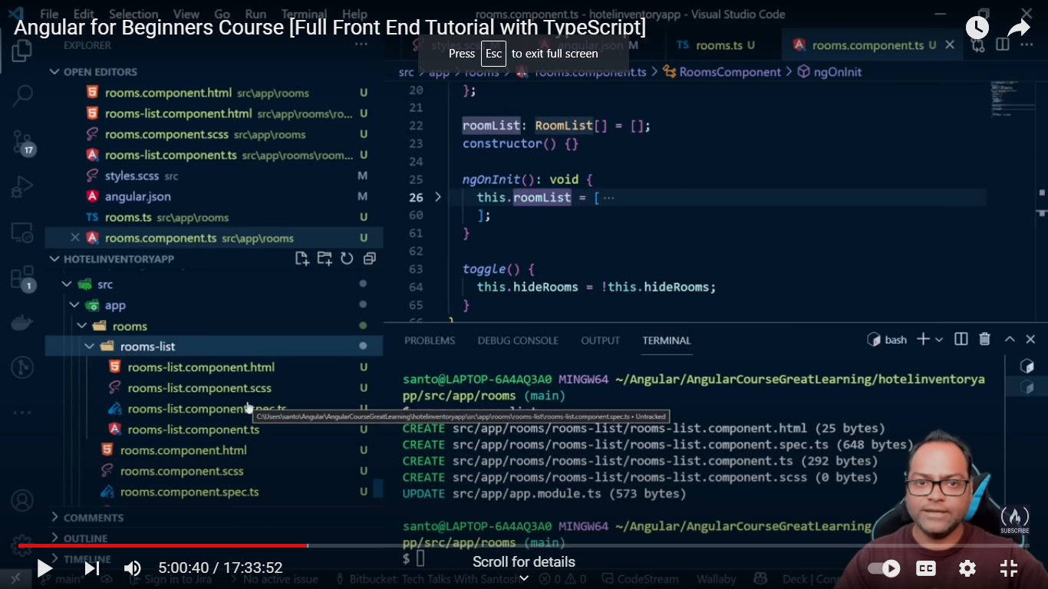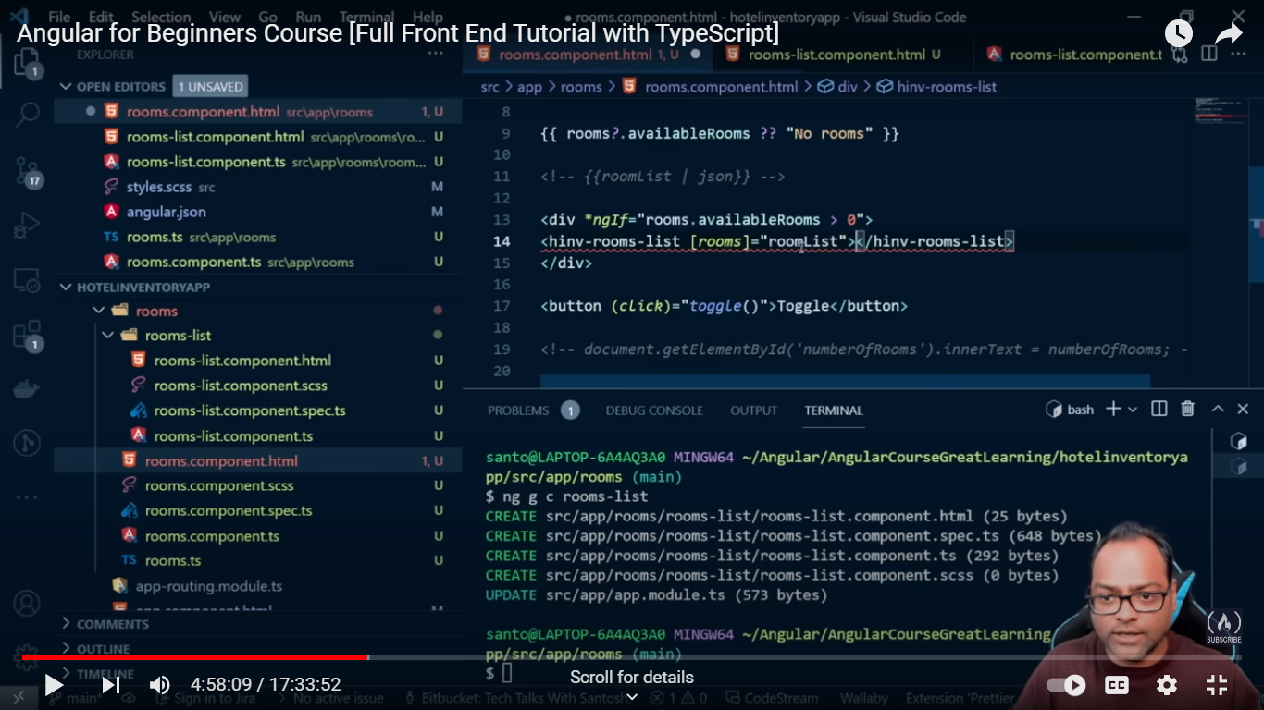

**Docheck:-**

**1.docheck decorator same functionality for ngoninit so don’t use this**

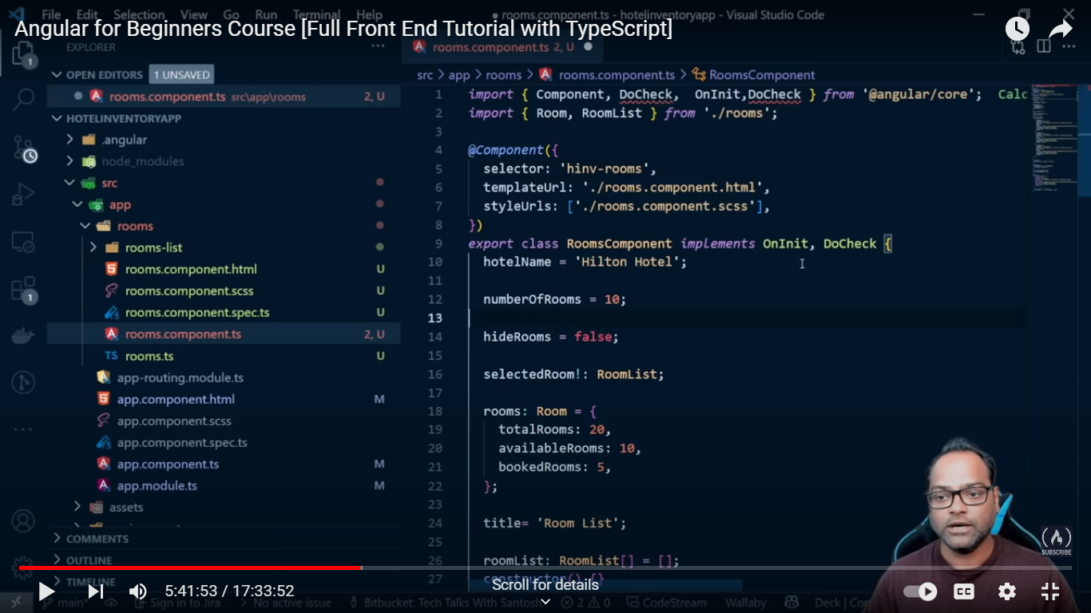

**@viewChild :-**

  @ViewChild('myDialogs') public templateRef : TemplateRef<any>;

**Insaide the component we have used to another component or model popup.**

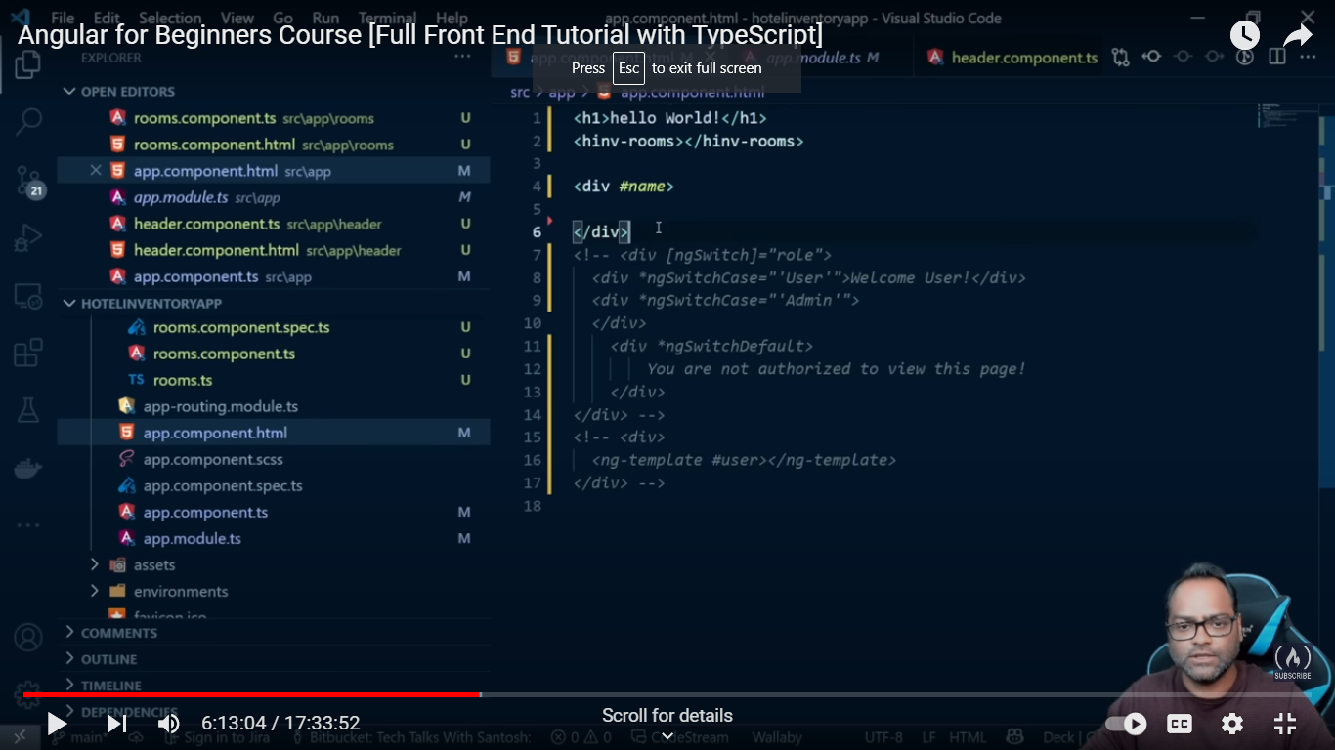

**Add the template reference without giving any content in div tag**

**Inside the ngOninit()**

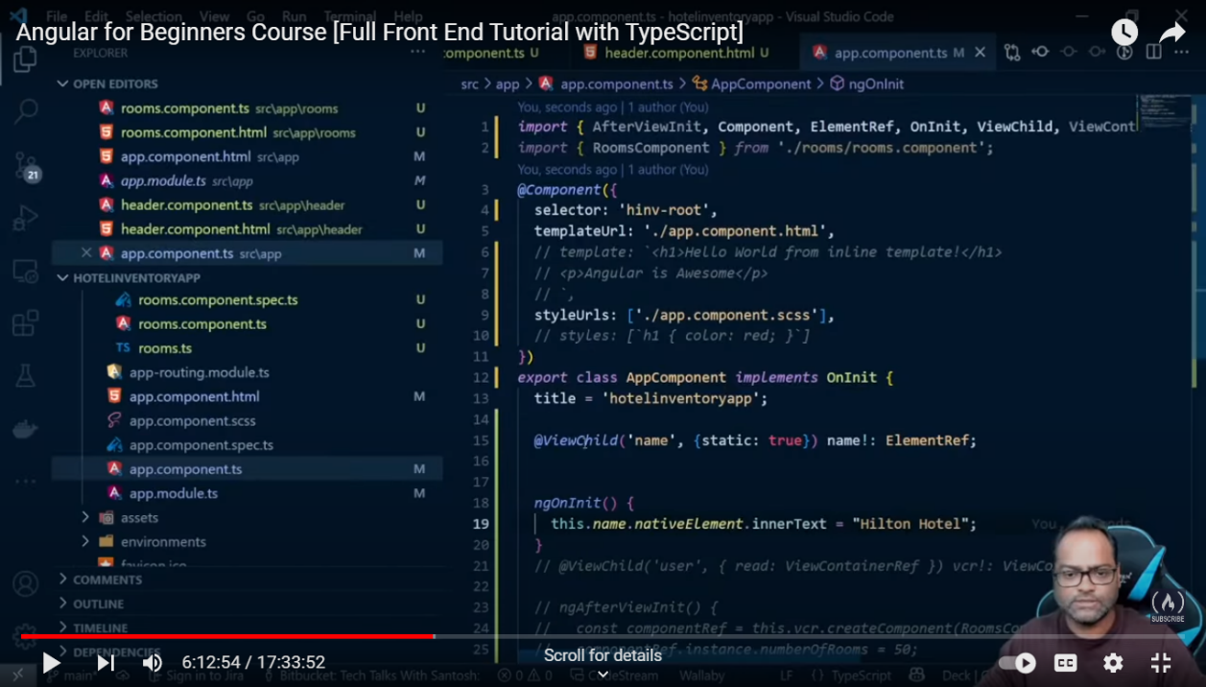

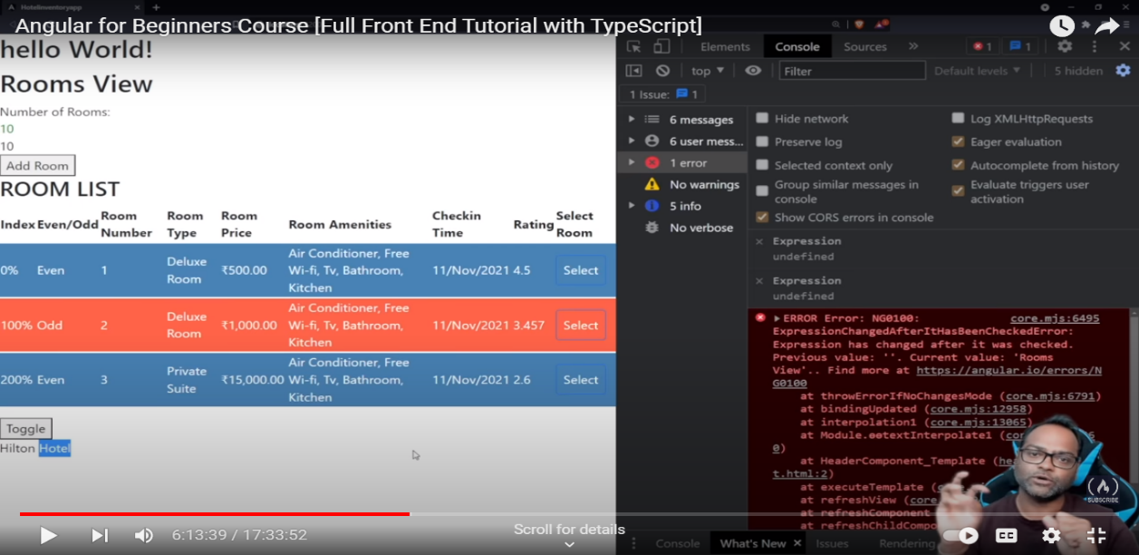

**@viewChild only show which is having first component .**

**@viewChildren show the multiple component.**

**DEPENDENCY INJECT:-**

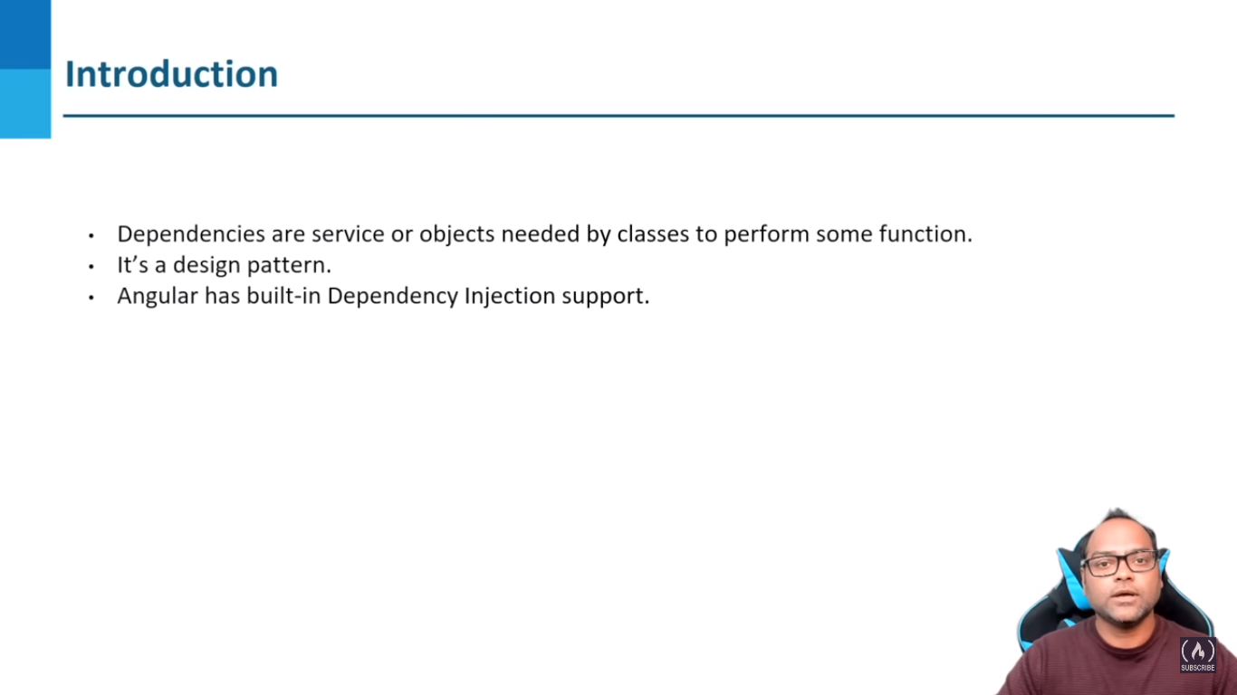

**1.If we write constructer to add the one service file we can should add the private only.**

**2.Otherwise we enter public the public can access the template file like html**

**RESOLUTION MODIFIER: -**

**Self.**

**Skip self.**

**Optional.**

**Host.**

**Searching:**

//npm i ng2-search-filter install then only  search works

<div class="search-bar">

    <input type="text" [(ngModel)]="searchText" placeholder="search here..." style="margin-top: 20px;margin-left: 400px; width: 250px;"  ><img src="https://img.icons8.com/ios-filled/1x/search--v4.gif" style="width: 25px; height: 25px;">

</div>

then searchfilter key for loopla podanum

<div *ngFor="let item of response |filter:searchText | paginate: { itemsPerPage: 8, currentPage: p }" class="item1">

**Paginator:**

NgxPaginationModule

1.Install .

2. <div style="margin-top: 30px; margin-left: 500px;"><pagination-controls (pageChange)="p = $event"></pagination-controls></div>

3.same ng for<div *ngFor="let item of response |filter:searchText | paginate: { itemsPerPage: 8, currentPage: p }" class="item1">

**Let And Var :**

**var:**

**var is function-scoped, meaning it is only accessible within the function in which it's declared.**

**let:**

**let is block-scoped, which means it is only accessible within the block (enclosed by curly braces) in which it's declared.**

**Example :**

**@Component({**

**selector: 'app-example',**

**template: `**

**<div>**

**<p>{{ message }}</p>**

**</div>**

**`**

**})**

**export class ExampleComponent {**

**constructor() {**

**if (true) {**

**var messageVar = "This is a var message";**

**let messageLet = "This is a let message";**

**}**

**console.log(messageVar); // Outputs "This is a var message" because of hoisting**

**console.log(messageLet); // Throws a ReferenceError because let is block-scoped**

**}**

**}**

**Chi;d to parent relationship**

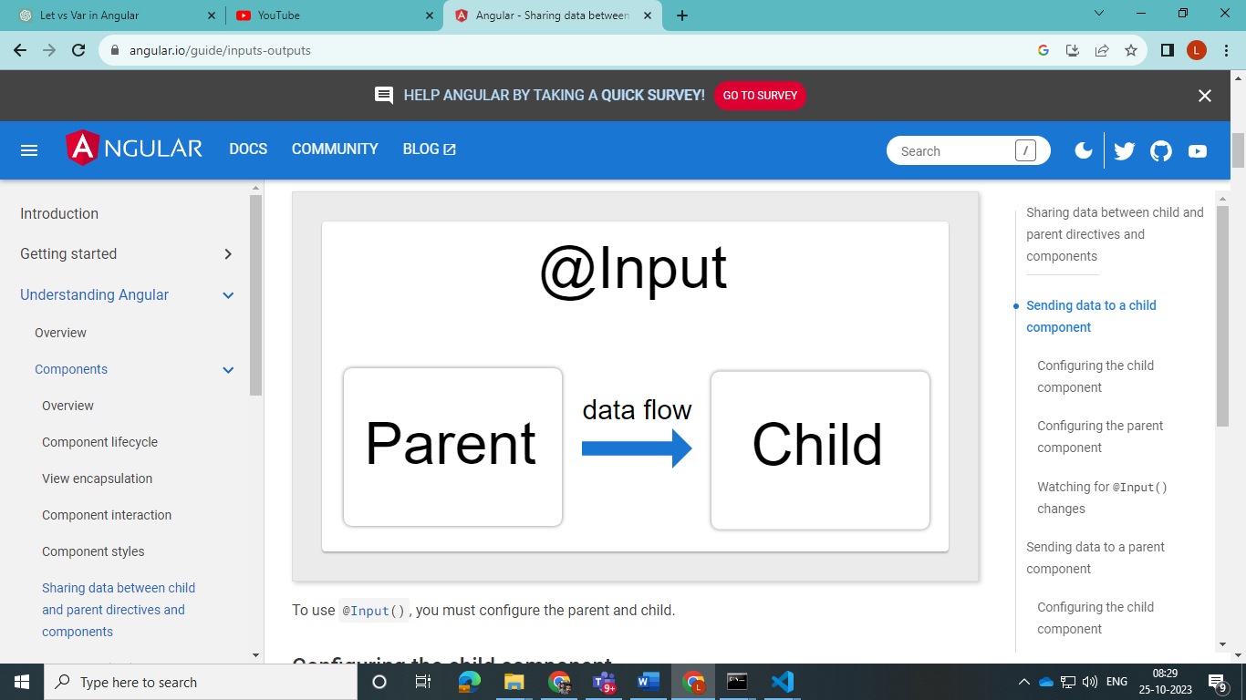

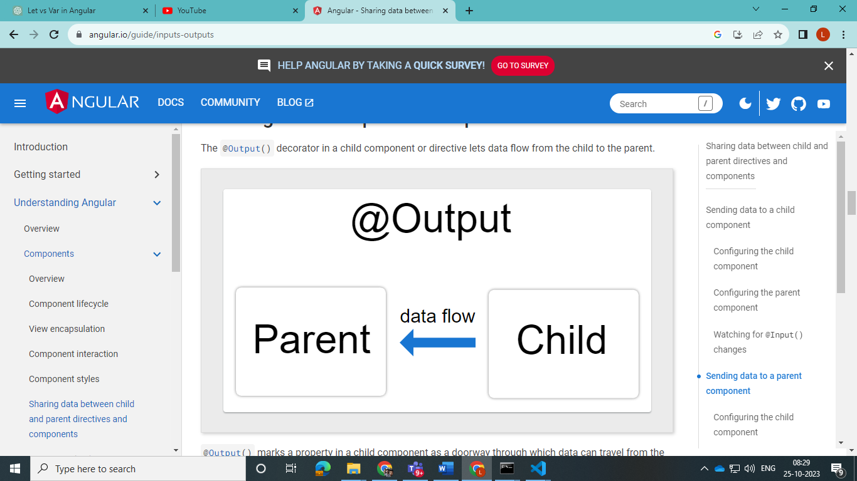

**Filter the Data**

**Ts File we create a filterData = ‘’;**

**In html search input [(ngModel)]=’filterData’**

**In *ngFor = let item of data |filter : filterData …………..filter means custom pipes.**

